**LINCOLN CITY CENTRE PARTNERSHIP | Company Number: 4662323 | trading as LINCOLN BUSINESS IMPROVEMENT GROUP** and **LINCOLN BIG**

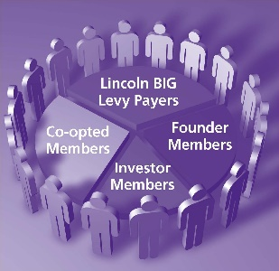Lincoln BIG (also referred to as the “Company”) is controlled by a Board of up to 19 Directors. Lincoln BIG is business-led; it is a trading company in its own right and operates under the same rules and procedures as any other business, although as a company limited by guarantee we do not distribute any profit, but plough this back into the aims and objectives of the business.

The articles of association of the Company require the Board to be representative of the local community and users of the services offered by the Company and that it comprises persons with a broad range of skills who are likely to contribute to the success of the Company. The Board is made up of different representatives.

There are three vacancies on the Board for Levy Payers. In the event of more candidates putting themselves forward for election to the Board than there are vacancies, an election will be held at the AGM to determine which candidates are to be appointed. That election will be by show of hands.

Please fill out the form overleaf if you wish to be considered at the Company’s AGM on 24 November 2025 at 5.30 pm for the position of a Director of the Company. The nomination form must be received by Lincoln BIG by 3 pm on Thursday 23 October 2025. To be considered for the position of Director you/the business in which you work must be a member of the Company.

To apply please complete the application form overleaf.

**The nomination form must be received by Lincoln BIG at BS1 The Terrace, Grantham Street, Lincoln LN2 1BD, or email** [**Sharon.Stone@lincolnbig.co.uk**](mailto:Sharon.Stone@lincolnbig.co.uk)**, by 3 pm on Thursday 23 October 2025**

**Application to become a Non-Executive Director**

|  |  |
| --- | --- |
| Full name: |  |
| Business name: |  |
| Business address: |  |
| Description of business: |  |
| Previous experience as a director: |  |
| What do you think you would bring to the role: |  |

In addition, you are welcome to also provide a curriculum vitae to illustrate your qualifications and experiences. You should **not** just send a CV on its own.

I, the above-named person, hereby consent to this nomination as a Director of Lincoln City Centre Partnership trading as *Lincoln Business Improvement Group*.

Signed: …………………………………………………………… Date: ……………….…………………….