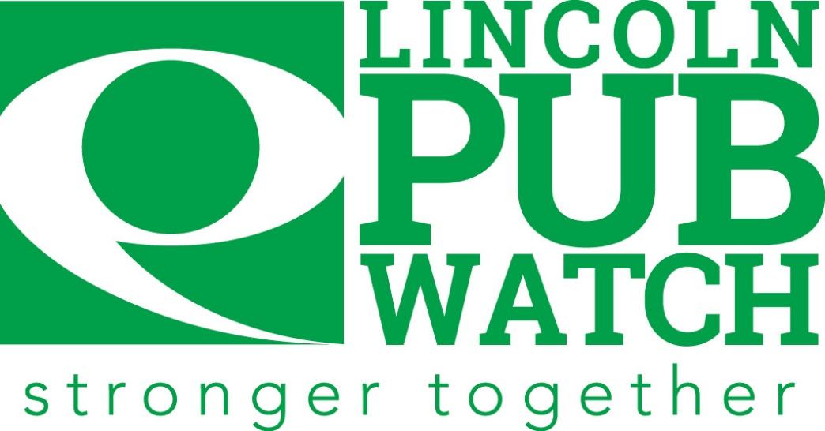
Constitution

Contents

1 | Introduction
2 | Aims and Objectives
3 | Purpose
4 | Criteria of Lincoln Pubwatch Membership
5 | Meetings
6 | Banning Individuals
7 | Disciplines
8 | GDPR Principles
9 | Exclusion Policy
10 | Lincoln Pubwatch Secretariat

- Introduction

Lincoln Pubwatch is a pro-active voluntary scheme of Licensees working in partnership with the Police and other related agencies to help combat crime, disorder, public nuisance, and anti-social behaviour.

- Aims and Objectives

  - To promote a safe, secure environment in all licenced premises and to help reduce alcohol related crime and anti-social behaviour within the city.

  - To assist members with upholding the four licencing objectives:

- Prevention of crime and disorder
- Prevention of public nuisance
- Public safety
- Protection of children from harm

  - To assist the Police, and other related agencies by better identifying problems relating to violence, criminal activity, anti-social behaviour, or disorder in and around licenced premises and increased communications.

  - To reduce offences in and around licensed premised by using Exclusion Orders or banning persons who have not behaved in an acceptable manner.

- Purpose

  - Lincoln Pubwatch will operate fairly and within all relevant laws only for the stated aims and objectives for which it has been created.

  - Each participant and contributor to the scheme is and remains bound by the Constitution and any subsequent amendments to it.

- Criteria for Lincoln Pubwatch Membership

  - Full voting members must be a Licensee, Designated Premises Supervisor or Senior Manager of a venue with an on-trade premises licence within the defined area as set out by the Lincoln BIG Levy zone.

    - From July 2021 all new full voting members must be approved by the majority of existing full voting members.

  - Non-voting membership is available for venues and businesses that are part of the hospitality sector but do not fall into 4.1 (ie cafés, restaurants, taxi ranks, fast food outlets, late night shops or agencies that would benefit the hospitality sector with information sharing)

    - Non-voting members must be approved by a majority vote of full voting members.

  - As a voluntary scheme, full voting and non-voting members must remain active and abide by all decisions agreed at the meetings.

  - Inactive full voting members will be removed from the scheme after missing four consecutive meetings regardless of apologies being sent.

  - Full voting members must attend at least one meeting every quarter.

  - Full voting members knowingly allowing barred persons into their venue can be excluded from the scheme if they fail to maintain the ban once it has been highlighted to them.

  - Full voting members can be excluded from Lincoln Pubwatch for serious breaches of the licensing objectives, bringing the scheme in to disrepute and failing to uphold our aims and objectives

  - For a full voting member to be excluded a vote will be called and added to the agenda for the next available meeting, which they may attend. To be excluded from the scheme a majority of full voting members will carry the decision.

- Meetings

  - Meeting will be held on average every six weeks and can be held in person via Teams or a mixture of both.

  - All meetings will be chaired by an elected member of Lincoln Pubwatch.

  - All meetings, actions and decisions taken will be minuted.

  - Attending full voting members and non-voting members must have signed and agreed to adhere to the Constitution.

  - A special meeting can be called at the request of 25% of full voting members for a vote of elected members and/or changes to the Constitution. Attendance must be over 50% of full voting members for any actions to carry.

  - To nominate an individual to be excluded from venues, the following details need to be submitted via the app/website prior to the meeting:

- Full details of the period
- Date and detail of incident
- Police Incident number (If reported. A clear photo of individual if not)
Without this information the individual will not be considered or carried forward to the next meeting.

  - Excluded from one venue, excluded from all must be strictly upheld by all members.

  - Every full voting member has one vote per incident and has the right to abstain from any vote

  - The Police, Local Authority, Lincoln BIG as secretariate and any other related agencies have an advisory and supporting role and do not carry voting rights.

  - Under the General Data Protection Regulations (GDPR) it is the full voting members and the non-voting members responsibility to ensure that any information that is shared is fully protected by said member.

- Banning Individuals

  - The Licensee has a right under common law to exclude anyone from their licensed premises for whatever reason and as a member of Lincoln Pubwatch, this exclusion can be extended to all member premises.

  - Objectives for Extended Bans

    - To exclude persistent troublemakers, violent persons, and drug dealers from full voting members premises.

    - To protect staff and customers from acts of physical violence or threatening behaviour .and/or anti-social behaviour.

    - To protect property from acts of violence.

    - To reduce incidents of crime and fear of crime for the benefit of staff and customers.

    - To improve the economic and general environment of the area, and so improve prosperity within the area by promoting it as a safer place to socialise, invest and work.

    - No person will be discriminated against by reason of race, gender, disability or sexuality.

  - Members need to take the following into account when considering a ban:

    - The seriousness of the incident.

    - Restitution already taken if any (damage paid etc).

    - The feelings of the person(s) involved.

    - Any other relevant details.

  - The length of banning notices will be determined by the majority of full members based on the incident as per the table below:

Threatening Behaviour | 1 Year
Theft and/or Fraud | 2 Years
Theft and/or Criminal Damage | 2 Years
Violence and/or Criminal Damage | 3 Years
Drugs Possession | 1 Year
Drugs Supply and/or Violence | 3 Years
Any other serious offence not specified above | Up to a lifetime ban

These timescales are subject to any appeal. Correspondence with reference to this decision should be made in writing to Lincoln Pubwatch, PO Box 961, Lincoln LN5 5EZ

After the specified period the exclusion will expire, and the offender’s details will be removed from the database. The offender will be notified by letter (if an address is held on file) that even though their ban has expired each venue has the right to refuse the person entry without given reason.

  - Once the length of the ban has been determined full voting members will then vote on the following outcomes to decide whether to ban the individual, the majority will carry the vote.

    - Do nothing – you don’t feel the incident warrants a ban.

    - Send a letter/make contact and explain that their behaviour was unacceptable, any further breaches will result in a ban.

    - Ban the individual for the agreed time as set out in 6.4.

Full voting members can abstain from a vote if they know the individual, but they will still need to enforce the ban in line with the Constitution.

  - Any persons subject to a ban will (providing a current address can be provided) receive a signed letter outlining the ban and its length. This is subject to Lincoln Pubwatch having access to the said person’s address or if it is known to Lincoln Pubwatch.

  - Lincoln Pubwatch will endeavour, where possible, to notify in writing.

  - A ban can be lifted or reviewed at any time by the Lincoln Pubwatch full voting members.

  - A person subject to a ban can appeal in writing, once in a 12-month period, address to Lincoln Pubwatch stating their reasons for the appeal. The Chair will present to the Lincoln Pubwatch for consideration.

  - If a person fails to attend their appeal without informing the Committee, at least 48 hours in advance, he/she will forfeit the right to another appeal within a 12-month period.

  - Offenders have the right to obtain a copy of all the personal data which Lincoln Pubwatch holds about him/her. Offenders must contact the Data Controller and will be required to produce proof of his/her identity. Requests must be responded to within 30 days with full documentation to demonstrate compliance with GDPR.

- Disciplines

  - Lincoln Pubwatch has specific responsibilities which should be fully understood by all full voting and non-voting members, partners, and their representatives.

  - The rules on confidentiality and GDPR must be the subject of written agreement and must be strictly adhered to.

  - Breaches of confidentiality and contravention of GDPR may lead to criminal prosecution and/or civil action for damages.

- GDPR

All members, partners and their representatives must be aware of the GDPR principles and abide by the principles to ensure no data breaches are made.

- Exclusion Orders

  - Exclusion Orders can be issued by the Magistrates Court if a person is convicted for an offence involving violence, drugs, or threatening behaviour. This would prohibit the person from entering specific premises or all premises within a defined area. The Magistrates Court will not issue orders automatically. The person reporting the crime must indicate their wish to the Court for them to impose the Exclusion Order to exclude that individual from all licensed premises within the Lincoln Pubwatch area.

  - It is important that Licensees or their staff alert the Police that they will require an exclusion order covering the Pubwatch area when reporting the crime.

  - Any person who commits any of the specified offences or threatens to do so, may be eligible for exclusion under the Lincoln Pubwatch Scheme:

    - Assault or threat of violence on the Licensee, staff or customers within or in close proximity to and linked to the member’s premises.

    - Being found in possession of controlled drugs within the member’s premises.

    - Being concerned with the supply, manufacture, or trafficking of a controlled drug in connection with any members premises.

- Lincoln Pubwatch Secretariat

Lincoln Business Improvement Group (Lincoln BIG) is the business improvement district for Lincoln with the area adjacent.
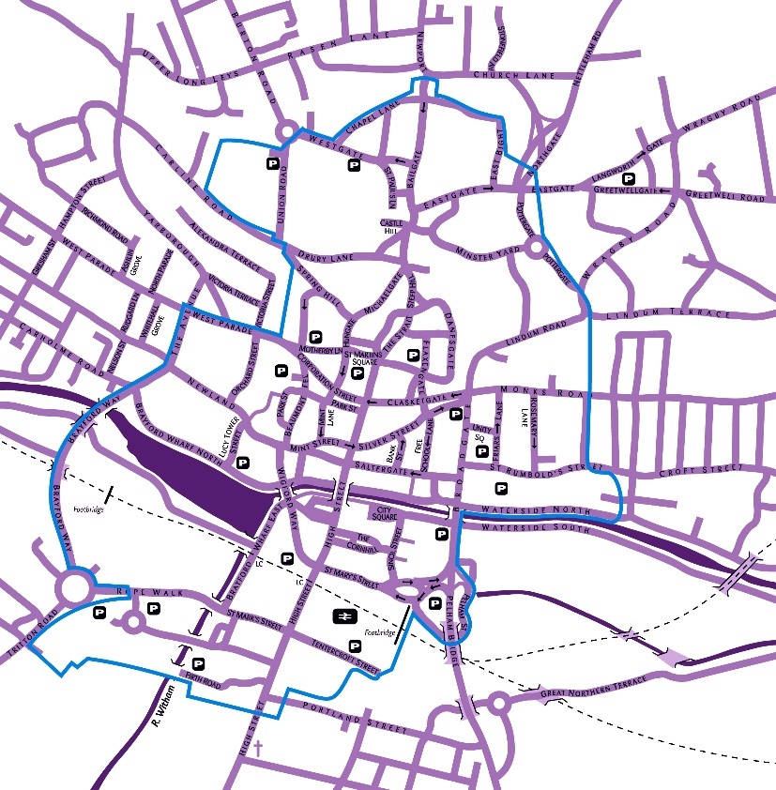
Lincoln BIG act as secretariate for Lincoln Pubwatch and have no voting rights as an outside agency. The role of secretariat is to organise meetings, agree the agenda with the Chair/ Committee and record the minutes and distribute.

Lincoln BIG also host the Lincoln Pubwatch PO box address and public liability insurance, of which they pay for to support Lincoln Pubwatch in keeping the city safe at night.

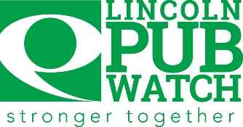
Lincoln Pubwatch
Full Voting Membership Form

Name of Premise
Address

Postcode

Name of Licensee/Manager
Email

Contact Tel No

Type of business

Names of Nominated Persons and their titles who will attend Pubwatch
Type of Premise

I/We agree to adhere to the Lincoln Pubwatch Constitution in its entirety.
I/We understand that the information used or shared within Lincoln Pubwatch is done so on the understanding that the recipient will adhere to the GDPR principles and under the GDPR Act. The content of meetings and minutes of said meetings are covered under this agreement and the need for confidentiality is paramount.
I/We understand the Codes of Practice for the use of photography files by Licenced Premises and that the photographs are released with the sole intention of preventing and detecting crime in Lincoln Pubwatch area; files will only be released to members of Lincoln Pubwatch upon receipt of the signature of the licensee or his/her manager; the Licensee must accept full responsibility for all data provided by the scheme and that all data is not permitted to be shared with non-members.
Signature |  | Name (Licensee/Manager)
Name of Premise |  | Date

One form to be completed, signed and returned to Lincoln Pubwatch and a copy to be retained by the Lincenced Premise.

