Piecing Us Together Trail Levy Payer Pledge Form

Thank you for expressing your interest for being involved in our ‘Piecing Us Together Trail’

The ‘Piecing Us Together Trail’ has been commissioned by Lincoln Creates 2022. The project idea originated from artist Mel Langton, who will also be designing and creating the trail, which consists of a 40-piece hand painted jigsaw puzzle. The trail involves pieces of the puzzle displayed in the windows of shops and businesses across Lincoln City Centre. Participating businesses will contribute to the creation of their puzzle piece character, as an interpretation of their business. The completed puzzle artwork will be a vibrant crowd scene with nods to local events. It is planned to launch shortly before October half-term and prizes will be available for people that complete the trail. To wrap up the project, the pieces will be reassembled and professionally framed on display in Lincoln City Centre.

What you can expect and what would be expected from participating in the ‘Piecing Us Together Trail’:

- Lincoln BIG will deliver your puzzle piece to your business between 3rd and 14th October 2022.

- You will need to ensure your 21cm puzzle piece is on clear display in your shop window on the provided wooden easel when the ‘Piecing Us Together’ trail goes live at the end of October. Lincoln BIG will collect your puzzle piece once the trail has ended. (Dates TBC)

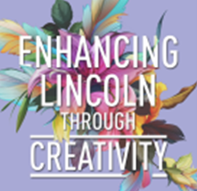
- Lincoln BIG will have updates and coverage on the trail through social media, please provide us with your username so we can include your business in posts. We encourage you to support the project at every opportunity both locally and further afield.

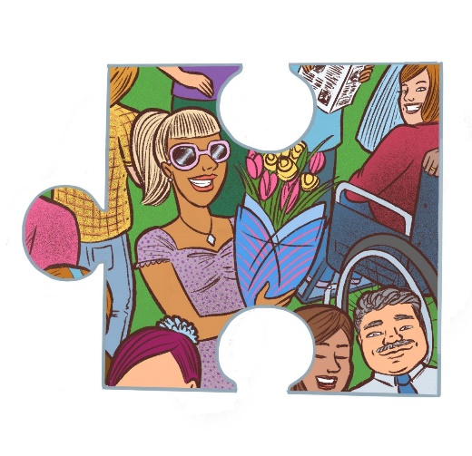 | Please share your ideas with Mel Langton on how you would like your character to appear as an interpretation of your business:  Neither corporate logos nor advertising is allowed. This does not include alterations to the entire puzzle piece, just for the character.
Please note, a design draft of how your piece will look within the full jigsaw will be sent to you before being created

Signed

Name
Business
Address
Contact No
Contact Email

Twitter |  | Instagram
Facebook |  | LinkedIn
Website

If you would like your business to be a part of this trail, please complete the form and return it via email to Olivia Dexter - OliviaDexter@lincolnbig.co.uk by Friday 5th August 2022 – 5pm.

